BIOLOGY
PAPER II
FORM 3 MARKING KEY
(40 MARKS)
- A science teacher brought a quadrat, pegs, notebook and a string to a form three class. Outline the procedure that could be followed when estimating a population of black jack in a playground using the materials.
Estimate the size of the study area (1)
Take a long string and stretch it across the selected area (1), using pegs hold the string (1)
Select the points along the line transect (stations) (1)
Place a quadrat at the first station of the quadrat (1)
Count the number of plants in each station (1), and record number of plants in the station (1)
Continue placing the quadrat in other stations ( 1) count and record number of black jack in each (1)
Sum up the total number of black jacks in all stations and divide by the number of stations made ( 1)

- Describe any five processes in nitrogen cycle
Fixation. Fixation is the first step in the process of making nitrogen usable by plants. Here bacteria change nitrogen from the air into ammonium. Lighting energy also contributes to nitrogen fixation into the soil.
Nitrification. This is the process by which ammonium gets changed into nitrates by bacteria. Nitrates are what the plants can then absorb.
Absorption. This is how plants gets nitrates from the soil to assimilate them into the cells of the plants in photosynthesis.
Feeding. This is where animals get nitrogen from plants. Animals loose nitrogen into the soil through decomposition or decay and through excretion.
Ammonification. This is part of decaying process. When a plant or animal dies, decomposers like fungi and bacteria turn the nitrogen back into ammonium so it can reenter the nitrogen cycle.
Denitrification. Extra nitrogen in the soil gets back into the air. There are special bacteria that perform this task as well. /Volcanic activities release trapped nitrogen back into the atmosphere 10 marks

- You are provided with specimens labeled M and N. (M reed and N mango leaf)
- (i) Which specimen belongs to monocotyledonous plants
M (reed)
- mark)
(ii) Give a reason for your answer.
Leaves have parallel veins (2marks)
- Explain any two adaptations of specimen M to its habitat.
Has hollow stem (1) to provide buoyancy (1)
Long stems (1) to allow them to reach above water for gas exchange (1)
Narrow leaves (1) to reduce water resistance (1)
Aerenchyma tissues (1) for support and gaseous exchange (1) (4 marks)
- Draw the specimen N and label any two parts.
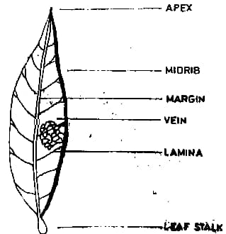

(3marks)
- You are provided with specimen X and Y. use them to answer the questions that follow.
- Identify specimen X and Y
X maize seed
Y bean seed
(2marks)
- Draw specimen Y and label any two parts
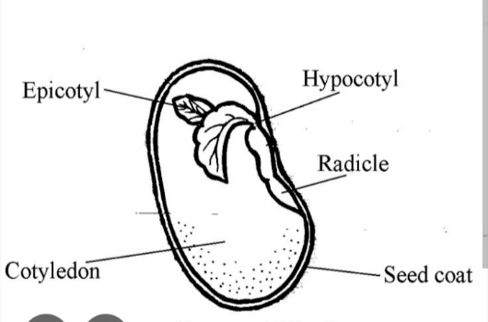

(3marks)
- Calculate the magnification of your drawing

Magnification = length of drawing / length of specimen
(4marks)
- Mention a deficiency disease that a child can suffer if lacking a nutrient present in specimen X. marasmus
(1mark)

